Literacy support worksheet

2.1 Mixtures are a combination of two or more substances

Pages 30–31 and 174

Mixtures

Part 1 – In the mix

What goes into a simple cup of tea?

1 This is a list of substances that make up a typical cup of tea: tea bag, milk, water, sugar, and a cup. Write ‘pure’ or ‘mixture’ next to each substance in the diagram below.

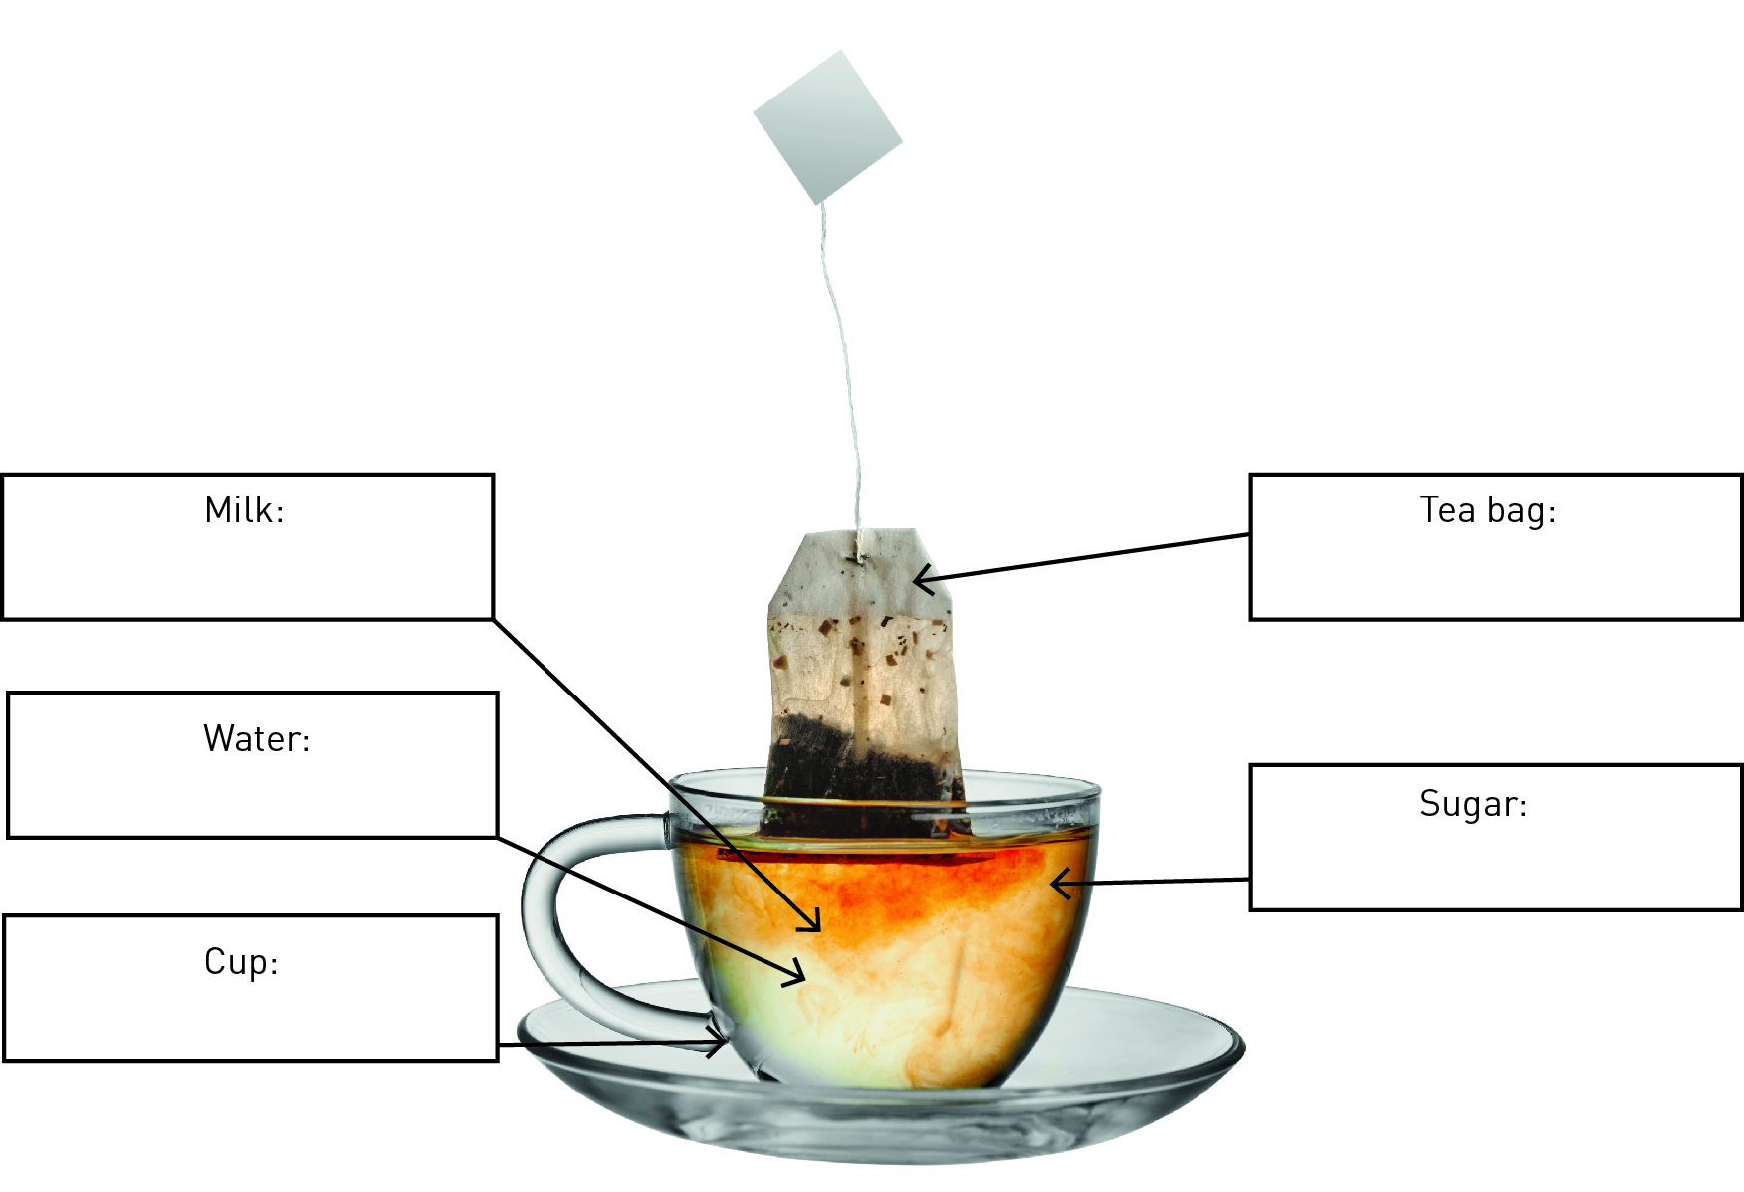

WORD DETECTIVE

2 Secret message

Use words from the student book to work out the secret message below:

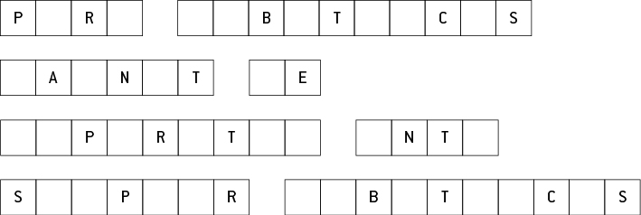

Part 2 – The suspense is building

3 The diagram below shows how small rocks and sand are carried by waves onto the beach.

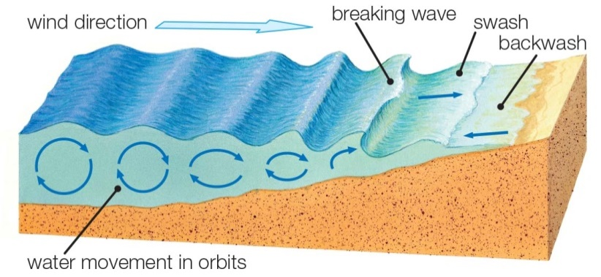

a Think about a beach you have visited. What types of materials are washed up onto the beach?

b What substances would be in *suspension* in seawater?

**WORD DETECTIVE**

4 Word search

Find the words listed, in the puzzle below.

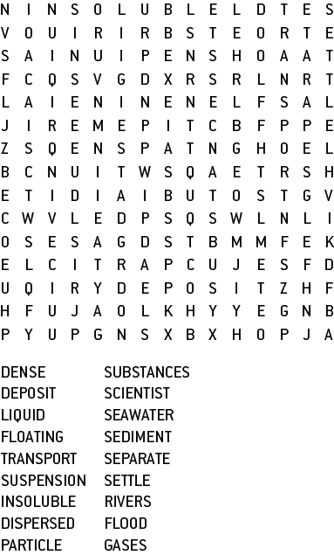

Part 3 – What are colloids?

A colloid is a suspension that does not separate easily.

5 Some drinks, for example chocolate-flavoured milk, are a mixture of a colloid and a suspension.

When you have chocolate-flavoured milk, you need to shake it before you open the container to drink it.

a Do you need to do the same to a container of plain milk before opening it?

b After you shake chocolate flavoured milk, it is a s_______________________. The milk doesn’t separate easily so it is also a c_______________________. In chocolate milk there are two liquids, so it can be called an e_______________________.

6 Draw and label four different examples of colloids below.

|  |  |
| --- | --- |
| a | b |
| c | d |

WORD DETECTIVE

7 Match-a-word

Draw a line from the words to their meanings.

Solution A suspension that doesn’t separate easily

Colloid Small pieces of solid that are spread through a liquid but don’t dissolve

Emulsion Contains tiny particles spread throughout it

Suspension A colloid of two or more liquids

Literacy support worksheet

2.2 A solution is a solute dissolved in a solvent

Pages 32–33 and 175–176

Is there a solution?

1 Use the word list below to name the main solute and solvent in the food or drink in the table.

Coffee granules Carbon dioxide gas Gravy granules Water Jelly crystals Chocolate

|  |  |  |
| --- | --- | --- |
| Substance | Solute (the substance that dissolves into a liquid) | Solvent (the liquid the substance dissolves into) |
| Hot chocolate |  |  |
| Black coffee |  |  |
| Instant gravy |  |  |
| Jelly |  |  |
| Soda (carbonated) water |  |  |

2 Solutions are generally see-through or transparent. Which of the foods or drinks above are solutions?

3 Look at the bottle and the jug below. Both have been filled with a blue solution, (like cordial) but one is more concentrated than the other.

a Draw a diagram showing the solute particles in each one.

|  |  |
| --- | --- |
|  |  |

b Which container has the lowest (or weakest) concentration?

c How could you make both the solutions more dilute (weaker)?

WORD DETECTIVE

4 Crossword

Read the clues below and place the correct answers in the crossword boxes.

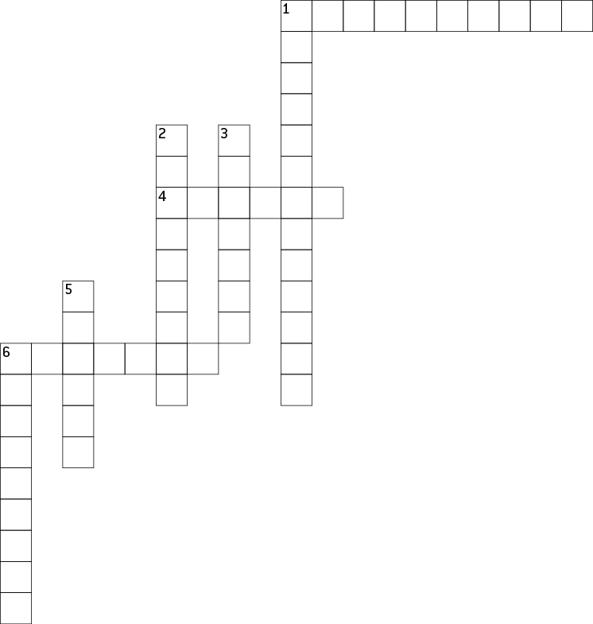

|  |  |
| --- | --- |
| **Across** | **Down** |
| 1 Contains carbon dioxide gas in water  4 A substance that dissolves in a liquid  6 When a substance dissolves in water | 1 The strength of a solution  2 When a substance cannot dissolve  3 Any liquid that dissolves another substance  5 A solution that is less concentrated  6 When no more solute can be dissolved |

Literacy support worksheet

2.3 Mixtures can be separated according to their properties

Pages 34–35 and 177–178

Separate properties

1 What process would you use to separate each of these mixtures?

|  |  |
| --- | --- |
| a |  |
| b |  |
| c |  |

2 Your science teacher brings a large bucket to class with water, sand, iron nails and grass clippings. Draw and write how you would separate this mixture using a different method for each step. Think about which method you would use first.

Bucket containing water, sand, iron nails and grass clippings.

WORD DETECTIVE

3 Secret message

Use words from the student book to work out the message below.

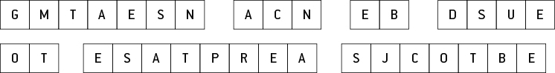

Literacy support worksheet

2.4 Mixtures can be separated according to their size and mass

Pages 36-37 and 179–180

Separating mixtures

1 Below are two different filters, a HEPA filter and a colander.

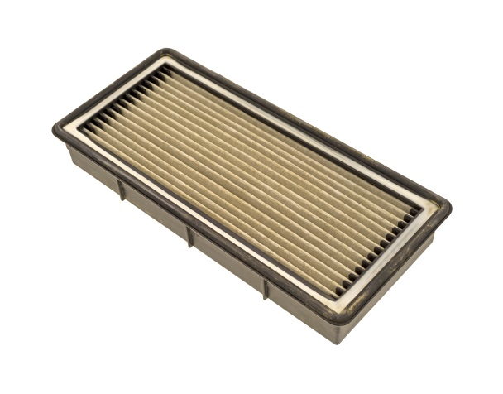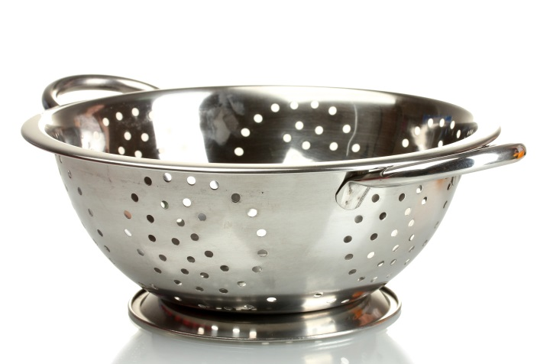

Describe at least two features both filters have in common.

WORD DETECTIVE

2 Secret message

Use words from the student book to work out the message below.

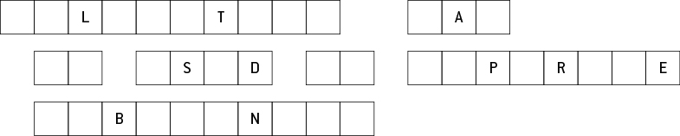

Literacy support worksheet

2.5 The boiling points of liquids can be used to separate mixtures

Pages 38–39 and 180–181

Going off the boil

1 Imagine you accidentally put sugar into a friend’s cup of tea. You decide to pour the cup of tea into a saucepan and boil it to separate the sugar from the tea.

a What method of separation are you using?

b What crystals would remain in the saucepan?

2 Draw a labelled diagram to show how this process of separation would work.

|  |
| --- |
|  |

3 The table below shows the boiling points of common liquids. Use the data to create a column graph ranging from the lowest to the highest boiling point in the space provided.

|  |  |  |  |  |  |  |  |  |  |  |  |  |  |  |  |
| --- | --- | --- | --- | --- | --- | --- | --- | --- | --- | --- | --- | --- | --- | --- | --- |
| |  |  | | --- | --- | | Liquid | Boiling point (°C) | | Water | 100 | | Alcohol | 78 | | Petrol | 95 | | Olive oil | 300 | | Tar | 300 | | Turpentine | 160 | |  |

4 The diagram below shows the equipment used for distillation in the science laboratory. Label the equipment described in the table.

|  |  |
| --- | --- |
| Equipment | Description |
| Flask | A bottle made of glass with a round body and a narrow neck |
| Tripod stand | A three-legged stand to support an object and keep it steady |
| Stand | A square support to keep an object steady |
| Bunsen burner | A small gas burner used as a source of heat |
| Test tube | A thin glass tube used to hold small amounts of material |

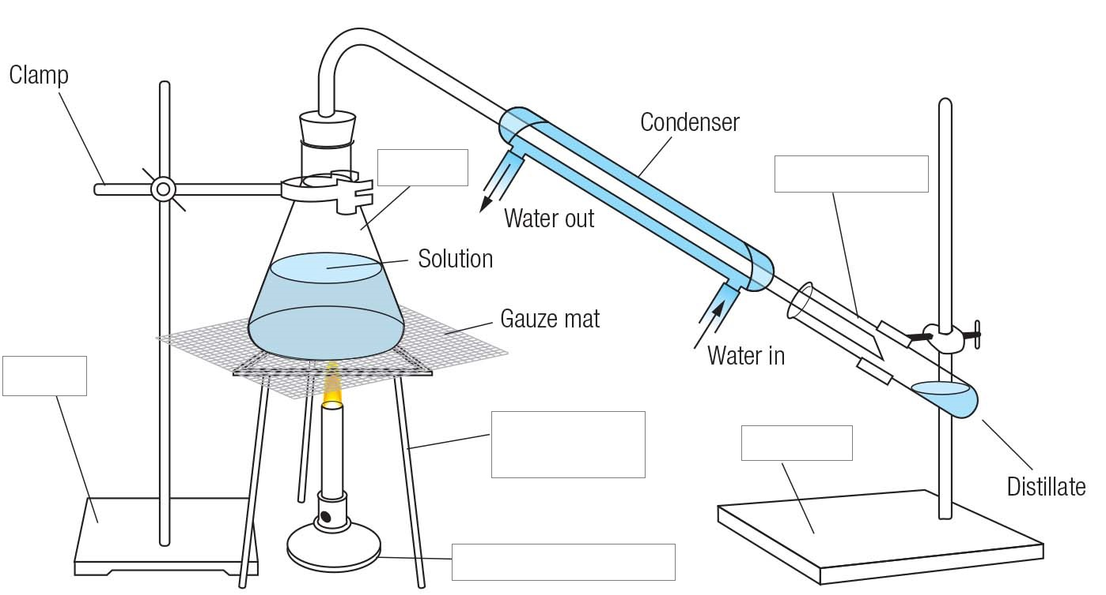

WORD DETECTIVE

5 Crossword

Read the clues below and place the correct answers in the crossword boxes:

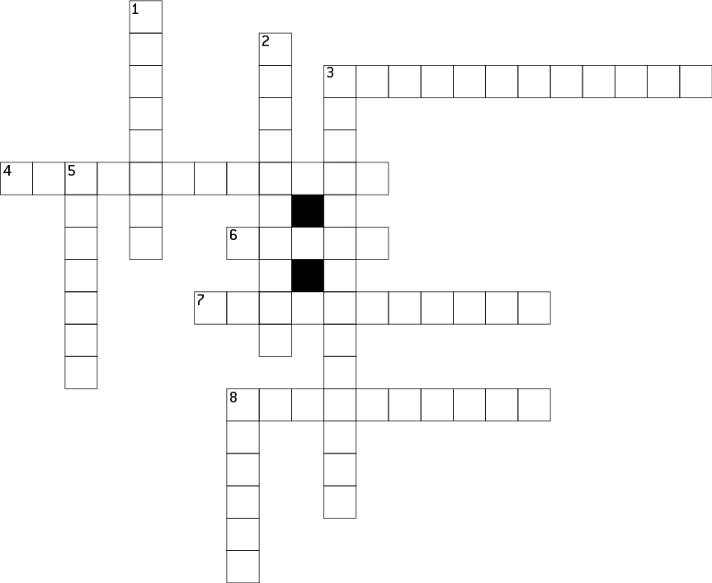

|  |  |
| --- | --- |
| **Across** | **Down** |
| 3 The change of state from a gas to a liquid  4 Uses evaporation and condensation to separate  6 Of the Sun  7 A change of state from liquid to gas  8 When two things have been made separate, they have gone through a _______________. | 1 Evaporation, crystallisation and distillation are used to separate the solvent from the solute in a _________.  2 Used to describe the distillation of crude oil  3 Separating chemicals, often by colour  5 Any liquid that dissolves another substance(s)  8 A substance that dissolves in a liquid |

Literacy support worksheet

2.6 Solubility can be used to separate mixtures

Pages 40–41 and 182–183

A mixture to dye for

1 In chromatography, the coloured dye that is most soluble is at the top of the paper, whereas the least soluble is at the bottom. The Rf value (retention factor) can be calculated as the distance travelled up the paper by a colour divided by the distance travelled up the paper by the solvent.

As an equation, $R_{f}=\frac{distance travelled by the colour}{distance travelled by the solvent}$

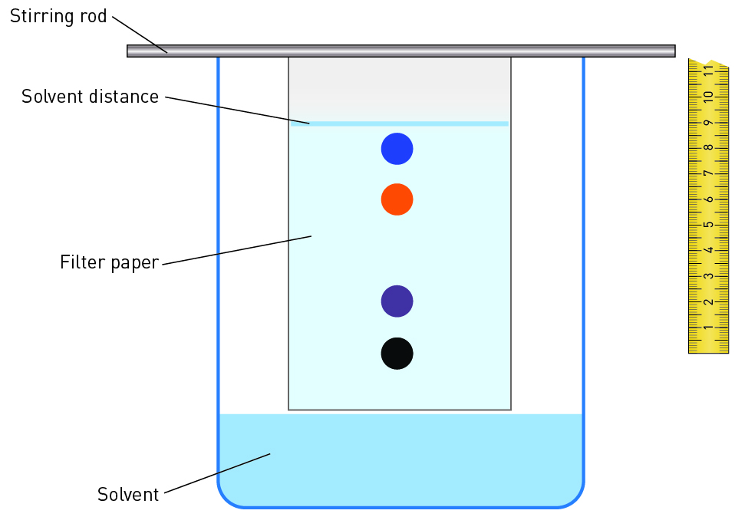

Calculate the Rf value for:

a purple

b orange

c blue.

WORD DETECTIVE

2 Match-a-word

Draw a line from the words to their meanings.

Evaporation A technique that uses evaporation and condensation

Distillation Separates dissolved substances (sometimes into different colours)

Chromatography The change of state from a gas to a liquid

Condensation A change of state from liquid to gas

Literacy support worksheet

2.7 Waste water is a mixture that can be separated

Pages 42–43

What a waste

1 Use the information on pages 42–43 and the words below to fill in the gaps in the diagram.

secondary chlorine filtrate residue

primary aluminium sulfate sedimentation bacteria

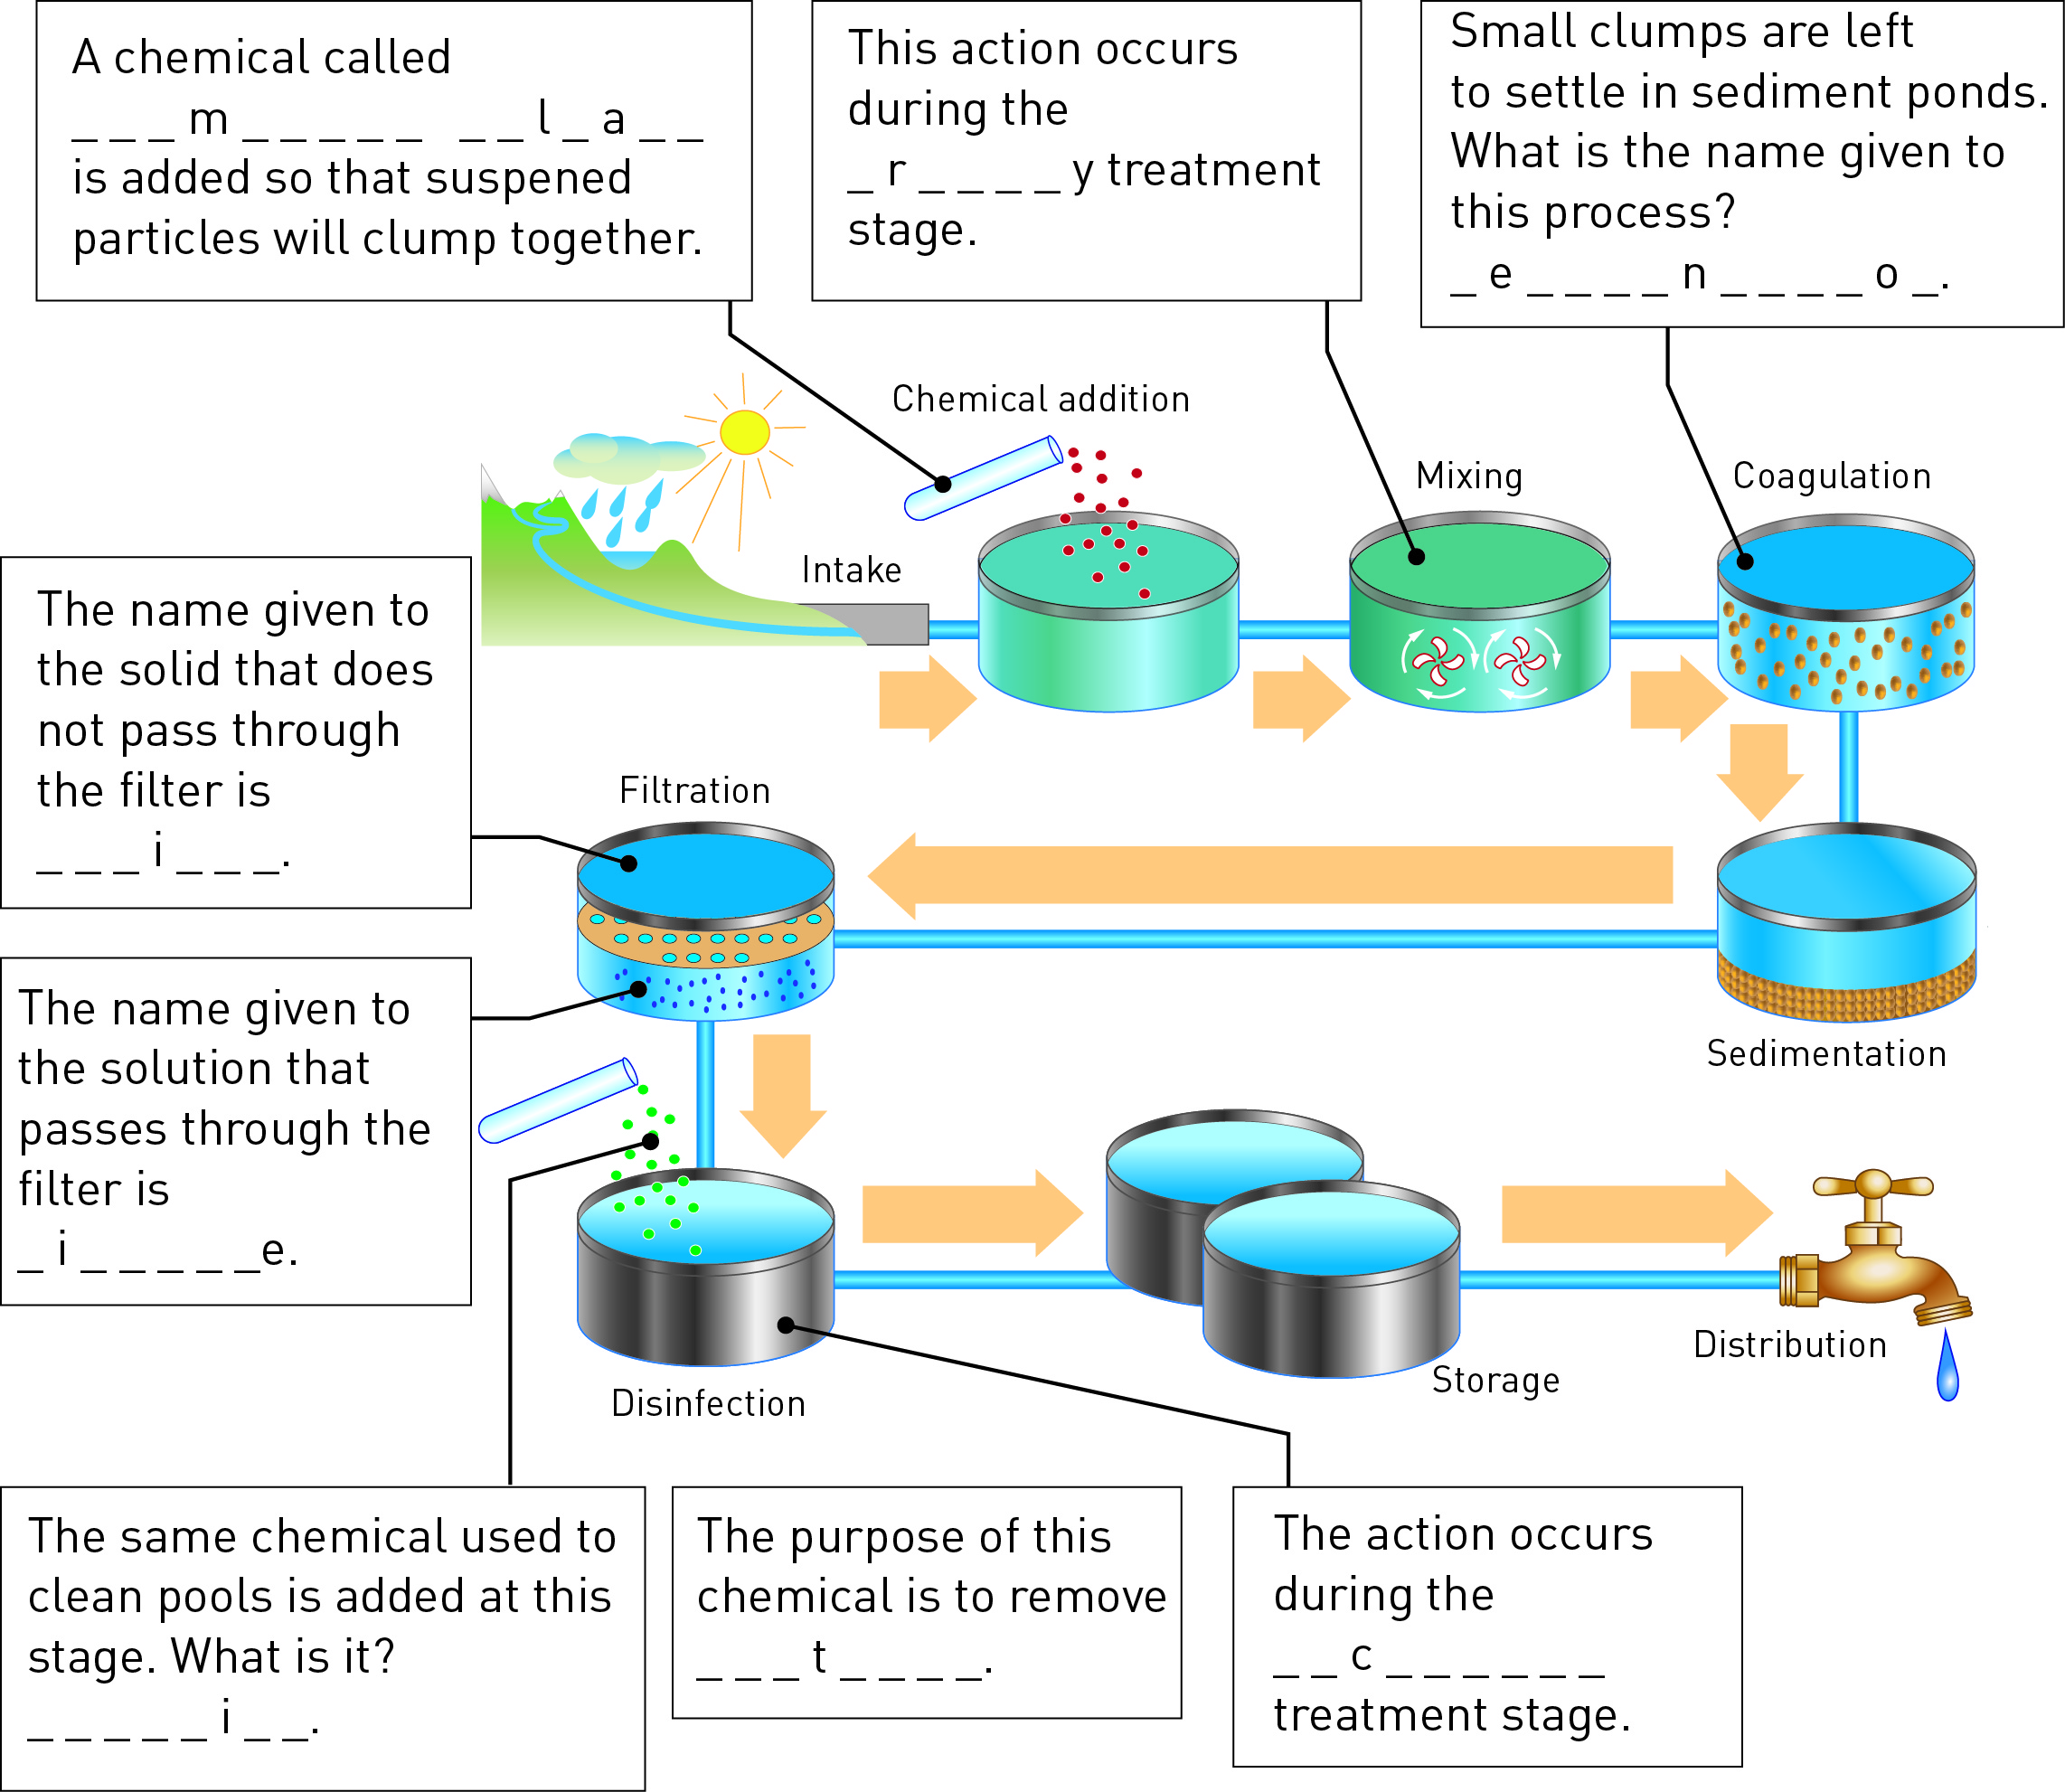

2 Secret message

Use words from the student book to work out the message below:

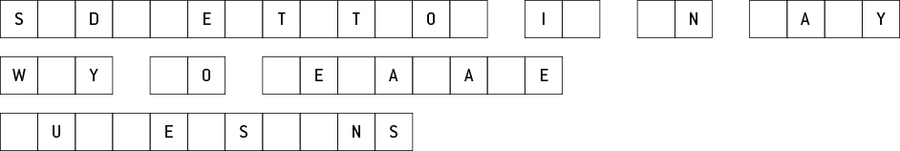

WORD DETECTIVE

3 Word search

Find the words listed, in the puzzle below.

